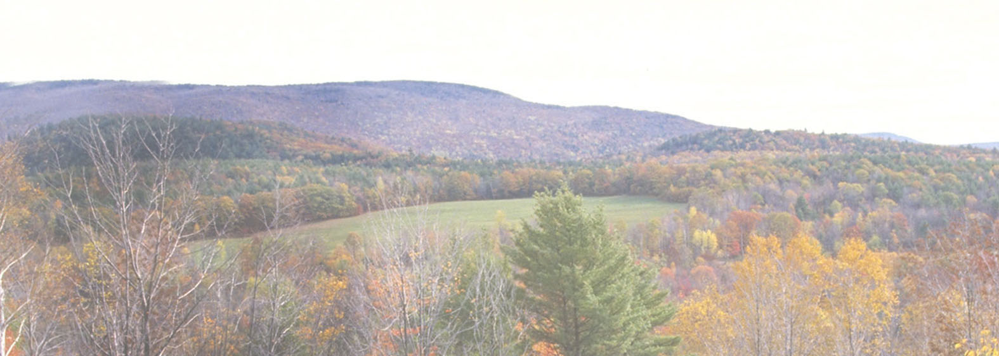
Fold here.
Deceased Name
Parlor

