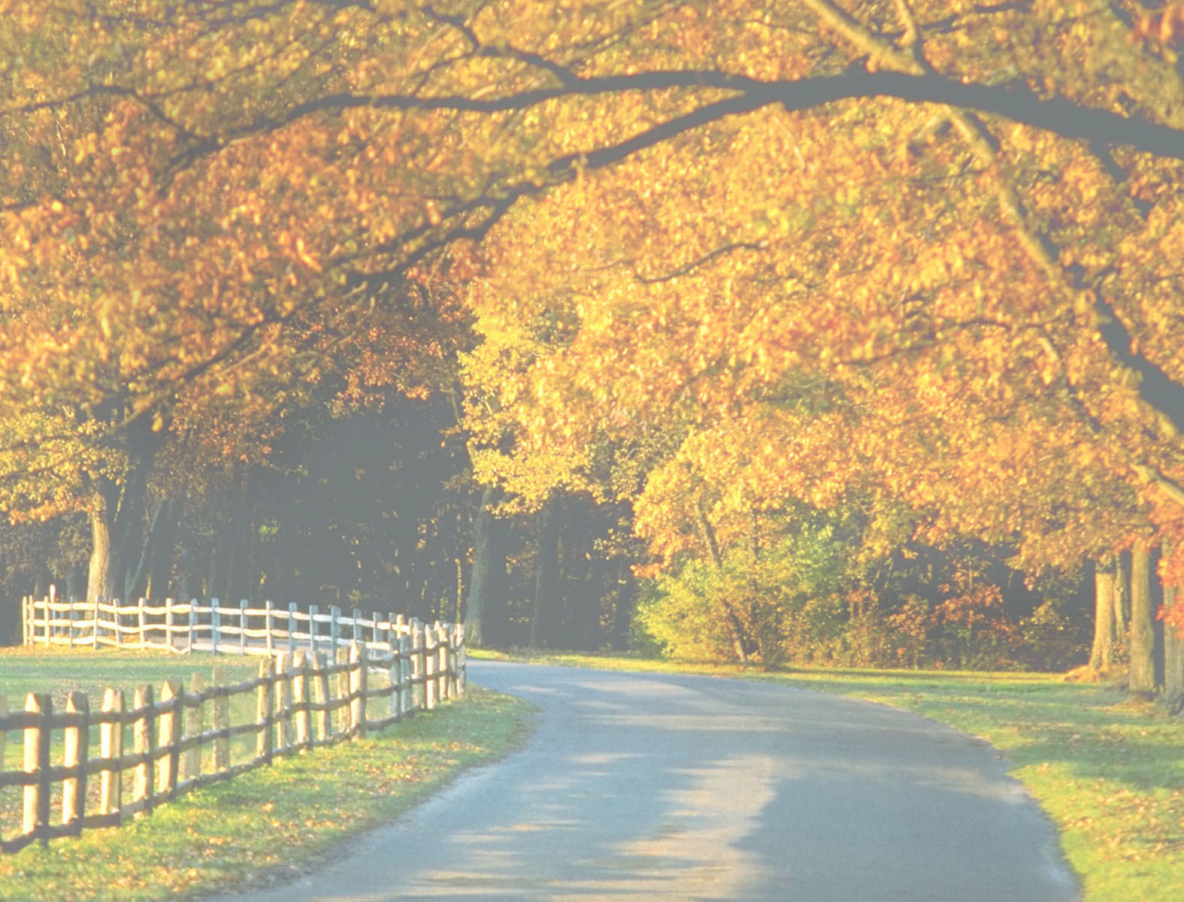
Service Information

Deceased Name
Parlor

