Reflections of Life Register Book Interior Instructions

1. Imprint Setup
Click on the “Imprint Setup” button to launch the template. Type the Funeral Home information in the box. Click save on the toolbar, then close template. Now all the templates that provide an area for the Funeral Home imprint will automatically import what you typed in the setup file. Note: Make sure imprint stays on one page, otherwise the imprint will truncate when linked.

2. Security Warnings
Document Links
You must click “Yes” to update the links for all templates. Otherwise the Funeral Homes imprint will not link to the template.
See below.
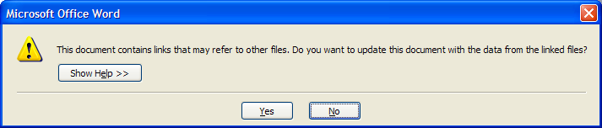
Macros
All templates contain macros. These templates will NOT function correctly without enabling them!
Check "Always trust macros from this publisher.”, and click “Enable Macros” when opening a template for the first time, this will only need to be done once.
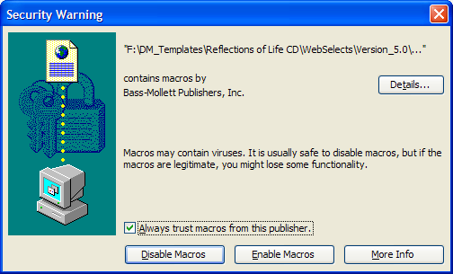
Note: If you do not receive this message and the templates are not working correctly, do the following.
Word 2000 – 2003
Click on Tools, Macros, Security, and make sure your security level is set to medium.
Then re-launch the template.
Word 2007 or above
Click on the office button (File), word options, trust center, trust center settings, and select “Disable all macros except digitally signed macros”. Click OK, and then re-launch the template.

4. Navigating to a Register Book Interior
Choose a template by matching the first page (the Title Page) to the images below. Then click on the image to go to that interior's selection page. Tip: You can also find the interior number by looking on your sales order or invoice The last part of the item number is the interior number example "RB363 6DK0"
If you cant find the correct template, please call 1.800.851.4046 and we can assist you.
5. Image Requirements
All images need to be scanned and saved to your computer prior to inserting them into the templates.
Bass-Mollett does not provide scanning capabilities.
- Sizes
  - Picture of the Deceased 2”x3”
  - Floral Images 2”x3”
  - Collage Images 2”x3”
  - Note: If correct sizes can not be obtained you an modify them in the template, by dragging the anchors on the image
- 200 dpi minumum

6. Toolbars
This toolbar was added to aid in using these templates. See descriptions of the buttons below.
For Word 2007 or above, users will need to click the “Add-ins” tab at the top of the page before seeing the toolbar below.
Some pages have more options than others, example: collage pages have option to insert emblems, verses etc.
Use these buttons to adjust the template when having printing alignment problems. Click on the button and the whole page will shift 1/32” in that direction.
Use these buttons to select all the text on the page and change it to any style your desire.
Use these buttons to delete the lines on the page along with the small text below the lines.
Use these buttons to save a copy of this template for later use and to print.

7. Filling Image Areas (Inserting Images)
Image areas in the templates are gray ovals or gray squares.
Use the instructions below to fill these areas with the desired image that you scanned earlier. See step 5
Word 2000-2003
Double click on the gray image area, select Format AutoShape, and choose the Colors and Lines tab. In the Fill area, click on the Color box and choose Fill Effects. Click on Picture tab, choose Select Picture. Find the desired picture, highlight, and click Insert. See Illustration below.
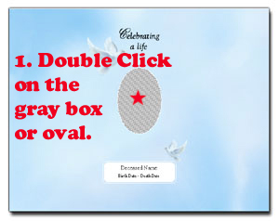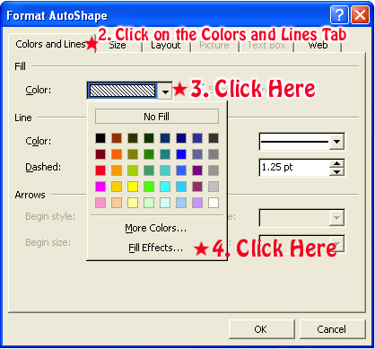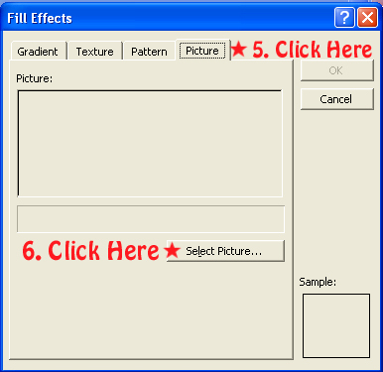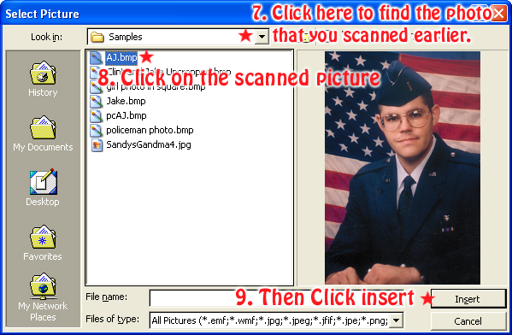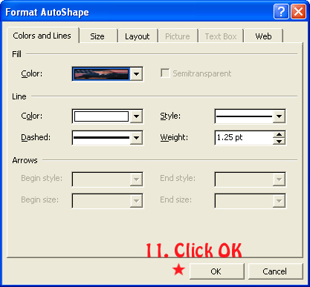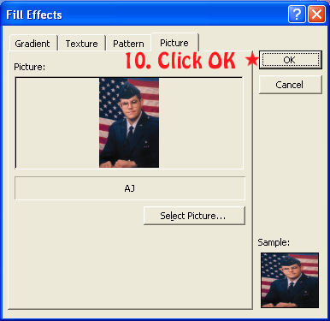

Word 2007 or above
Right click on the gray image area, select Format AutoShape, and choose the Colors and Lines tab. In the Fill area, click on the Color box and choose Fill Effects. Click on Picture tab, choose Select Picture. Find the desired picture, highlight, and click Insert. See Illustration below.
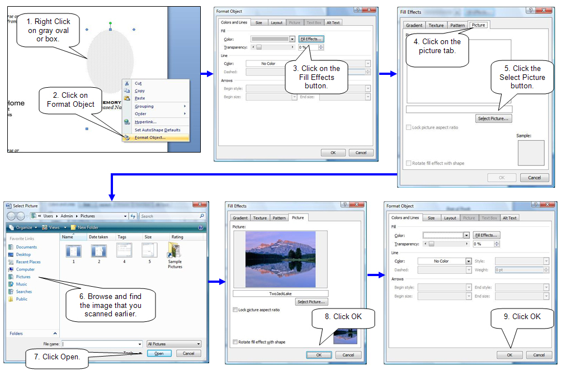
8. Changing the shape of the picture.
Click on the desired shape in the toolbar to change all the images shape.
See section 6 of this document.
9. Filling in text boxes (Typing in your information)
Click on the first line on the page and start typing, text boxes are linked so just hit enter to go to the next line.
Or you can click on each line that you want to type text on.

10. Inserting Verse (From Custom Verse Library) Use the Service Record Section
The custom verse templates allow for typing a custom verse on the fly, or inserting any of your verses that you have added to the library “see section 3 of this document”. Click on the custom verse button on the toolbar “see section 6 of this document” and choose desired verse, click ok after insertion the verse can be edited further if desired.
Note: If you change the verse after insertion, change only the first one in the template and use the duplicating options button to update the other verses on the page. See section 6 of this document.
10. Saving template.
Saving the template for later use is a good practice incase the need for more pages.
Click Save on the toolbar and browse to the desired location. Example: My Documents.
See section 6 of this document.

11. Printing
Due to the fact of many different printer configurations some adjustment may be needed when printing.
Printing tip: Due to the custom size of these pages, they are to be printed using the manual feed tray on your printer.
Consult your printer’s documentation on how to print custom page sizes.
Each page size is on top each interiors template page.
If further instructions are needed, please contact us.

1.800.851.4046
Bass-Mollett Publishers, Inc.

