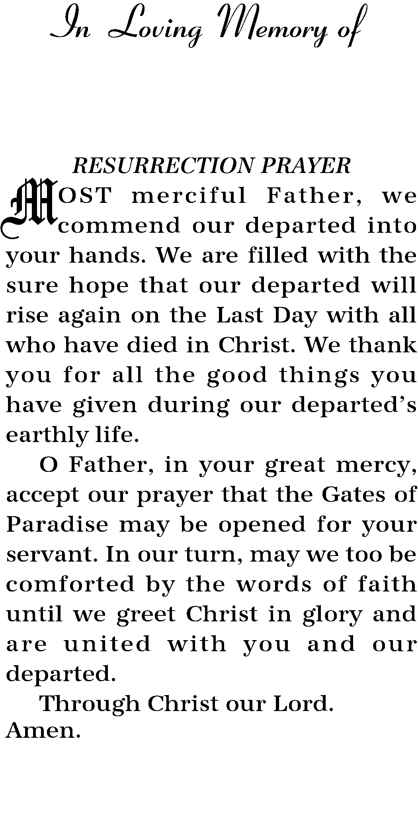
In Loving Memory of
Deceased Name
Date of Birth Date of Death

In Loving Memory of
Deceased Name
Date of Birth Date of Death

In Loving Memory of
Deceased Name
Date of Birth Date of Death

In Loving Memory of
Deceased Name
Date of Birth Date of Death

In Loving Memory of
Deceased Name
Date of Birth Date of Death

In Loving Memory of
Deceased Name
Date of Birth Date of Death

In Loving Memory of
Deceased Name
Date of Birth Date of Death

In Loving Memory of
Deceased Name
Date of Birth Date of Death

