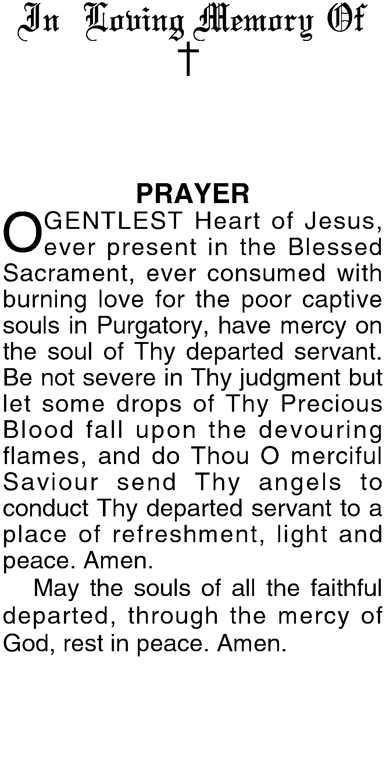
In Loving Memory of

Deceased Name
Date of Birth
Date of Death

In Loving Memory of

Deceased Name
Date of Birth
Date of Death

In Loving Memory of

Deceased Name
Date of Birth
Date of Death

In Loving Memory of

Deceased Name
Date of Birth
Date of Death

In Loving Memory of

Deceased Name
Date of Birth
Date of Death

In Loving Memory of

Deceased Name
Date of Birth
Date of Death

In Loving Memory of

Deceased Name
Date of Birth
Date of Death

In Loving Memory of

Deceased Name
Date of Birth
Date of Death

