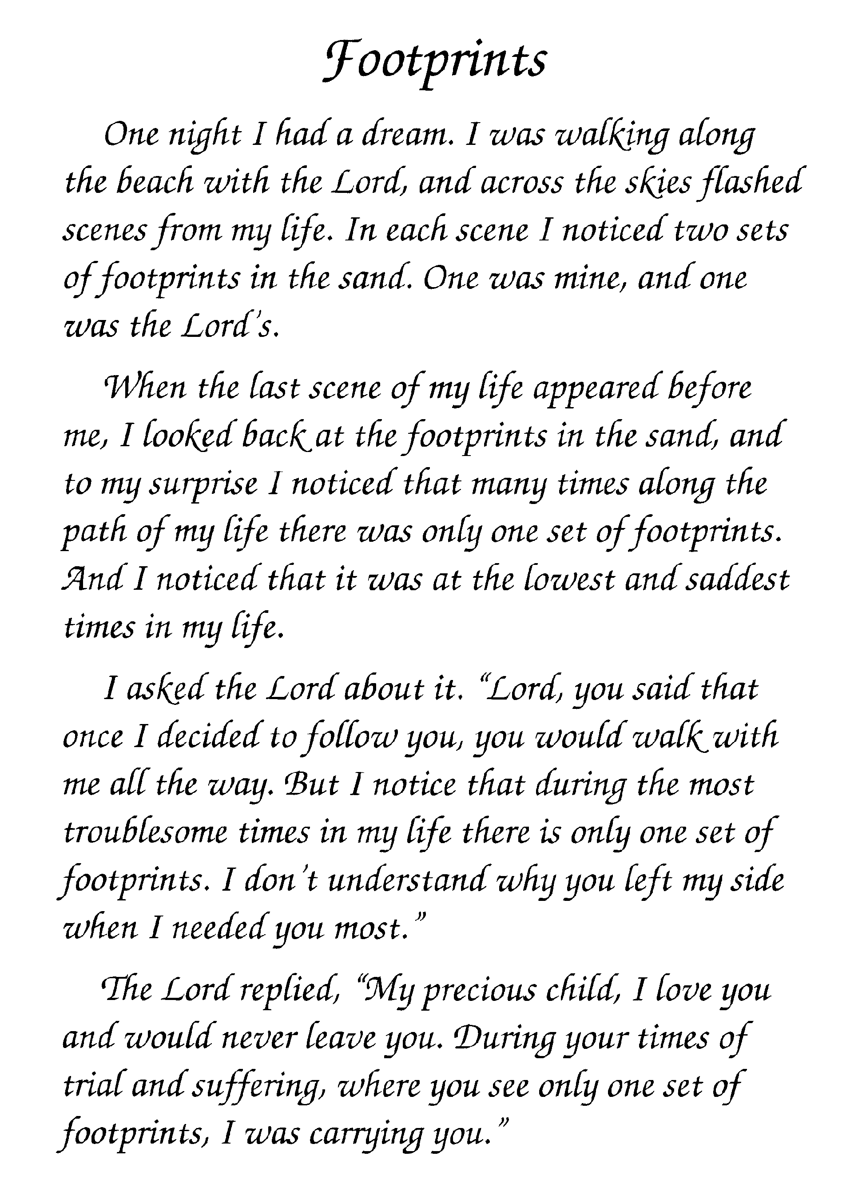
In Memory of
Deceased Name

In Memory of
Deceased Name

