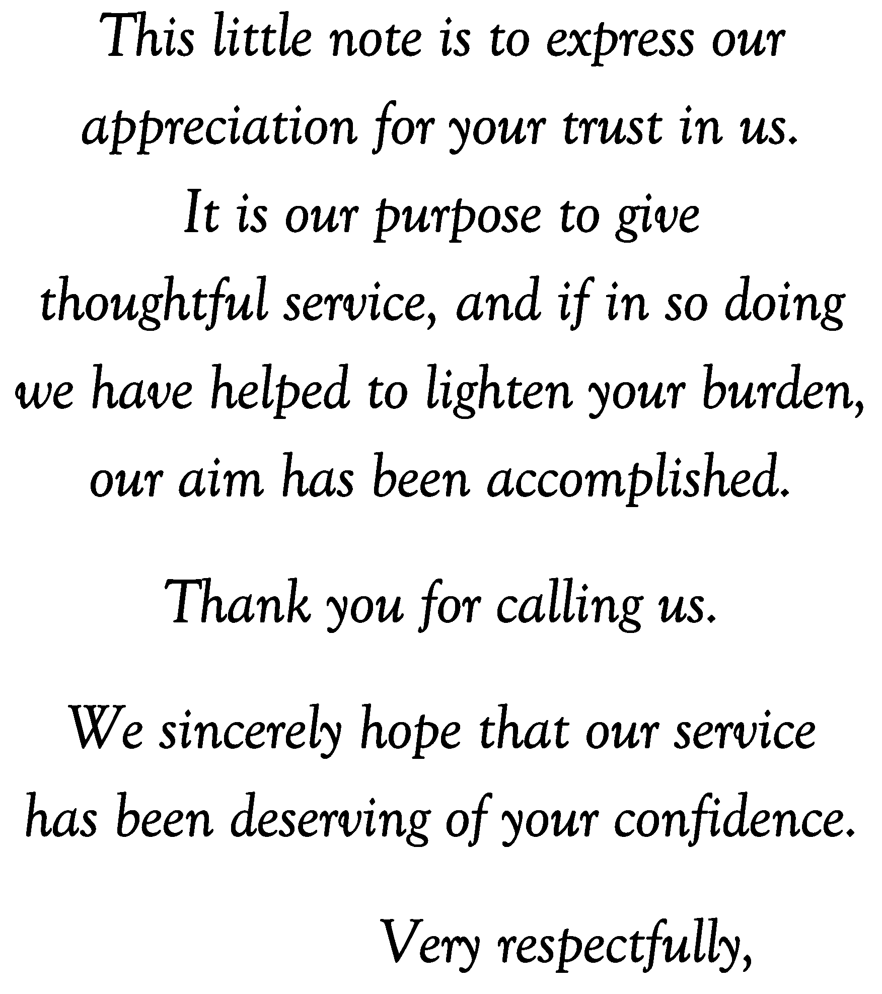
Replace text with a verse or statement, if not highlight and delete text.
Replace text with a verse or statement, if not highlight and delete text.
Replace text with name or highlight and delete.
Replace text with name or highlight and delete.

