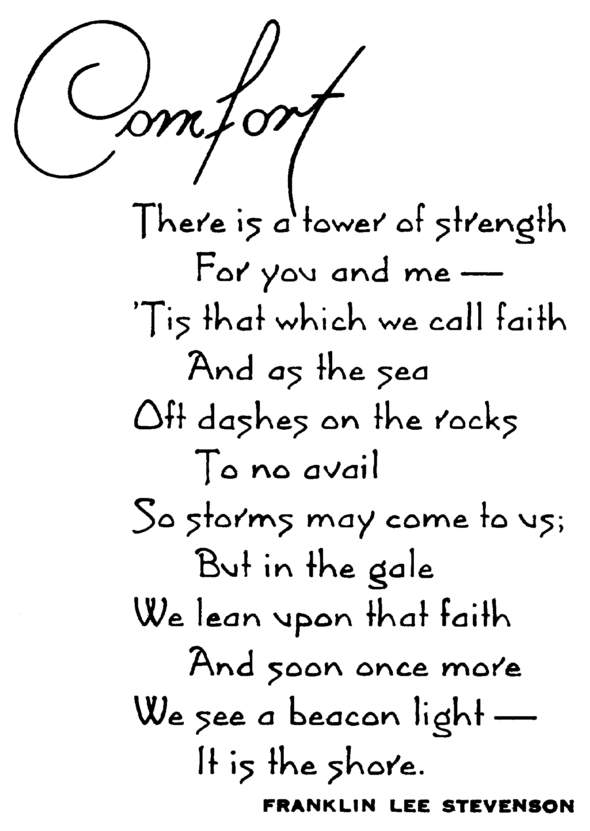
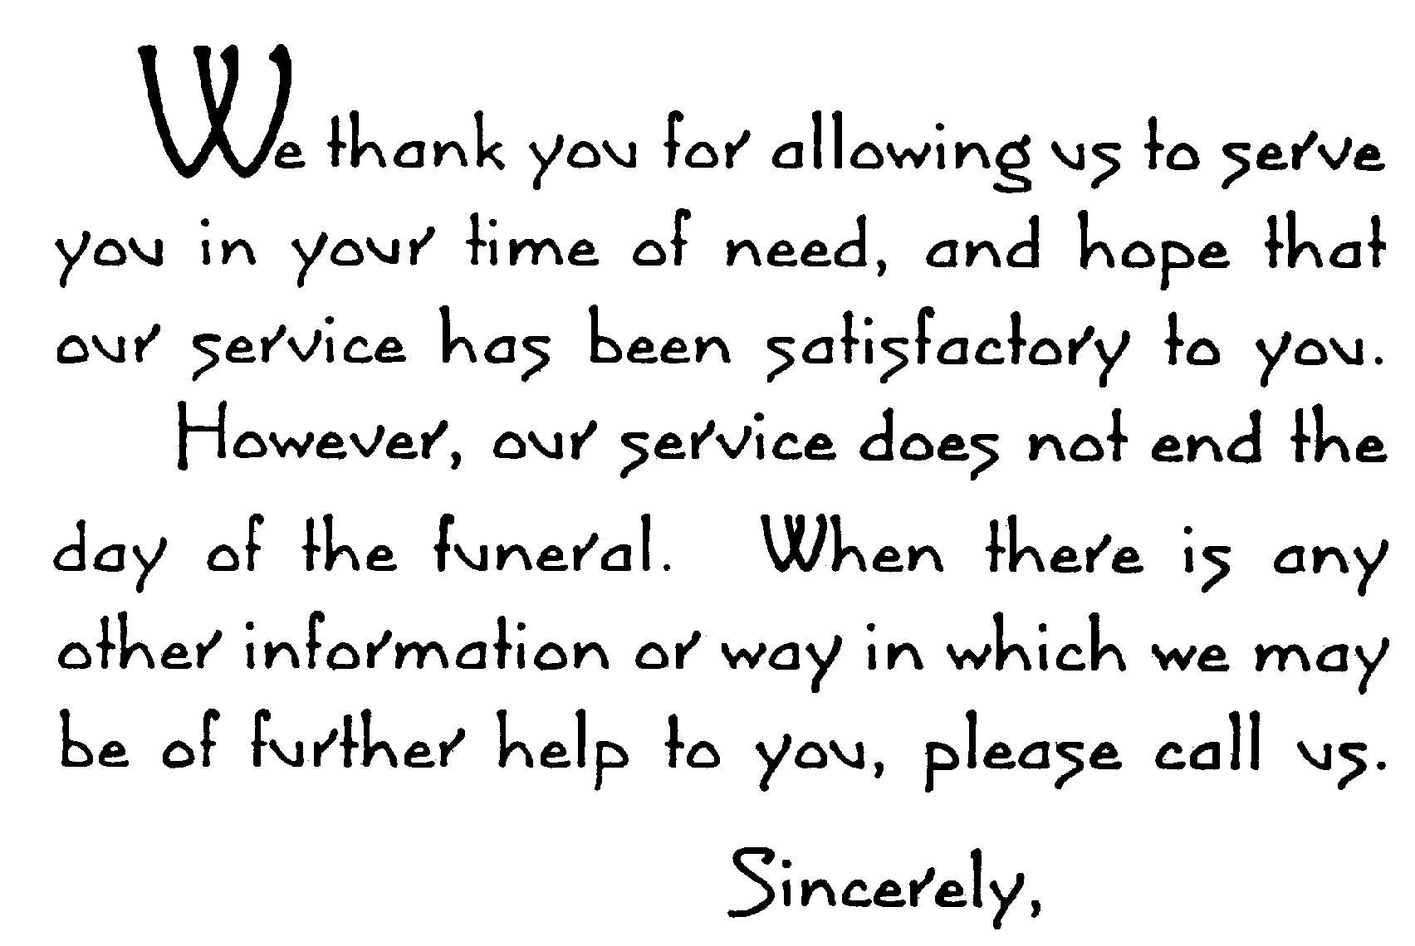
Replace text with name or highlight and delete.
Replace text with name or highlight and delete.

