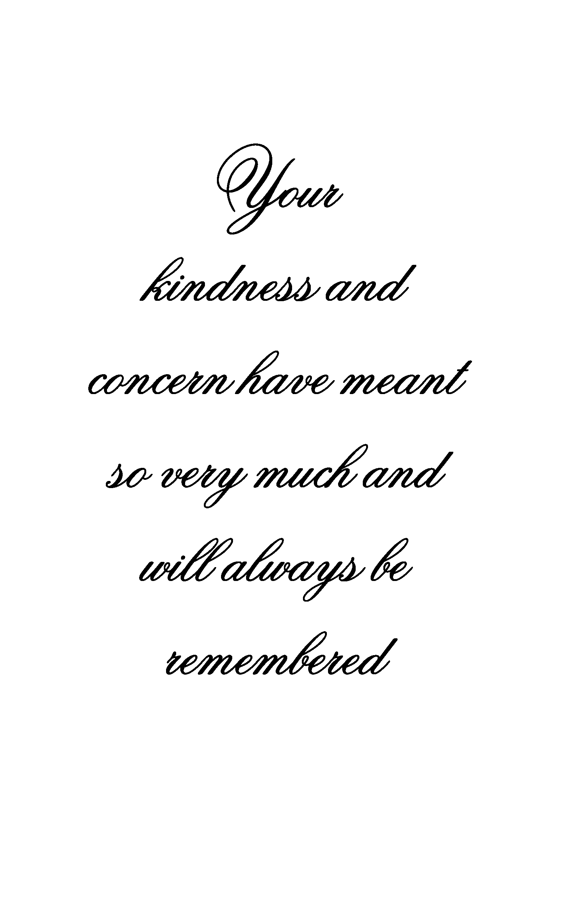
Replace text, with a statement. If not highlight and delete
Replace text, with a statement. If not highlight and delete
In Loving Memory Of
Deceased Name
In Loving Memory Of
Deceased Name

