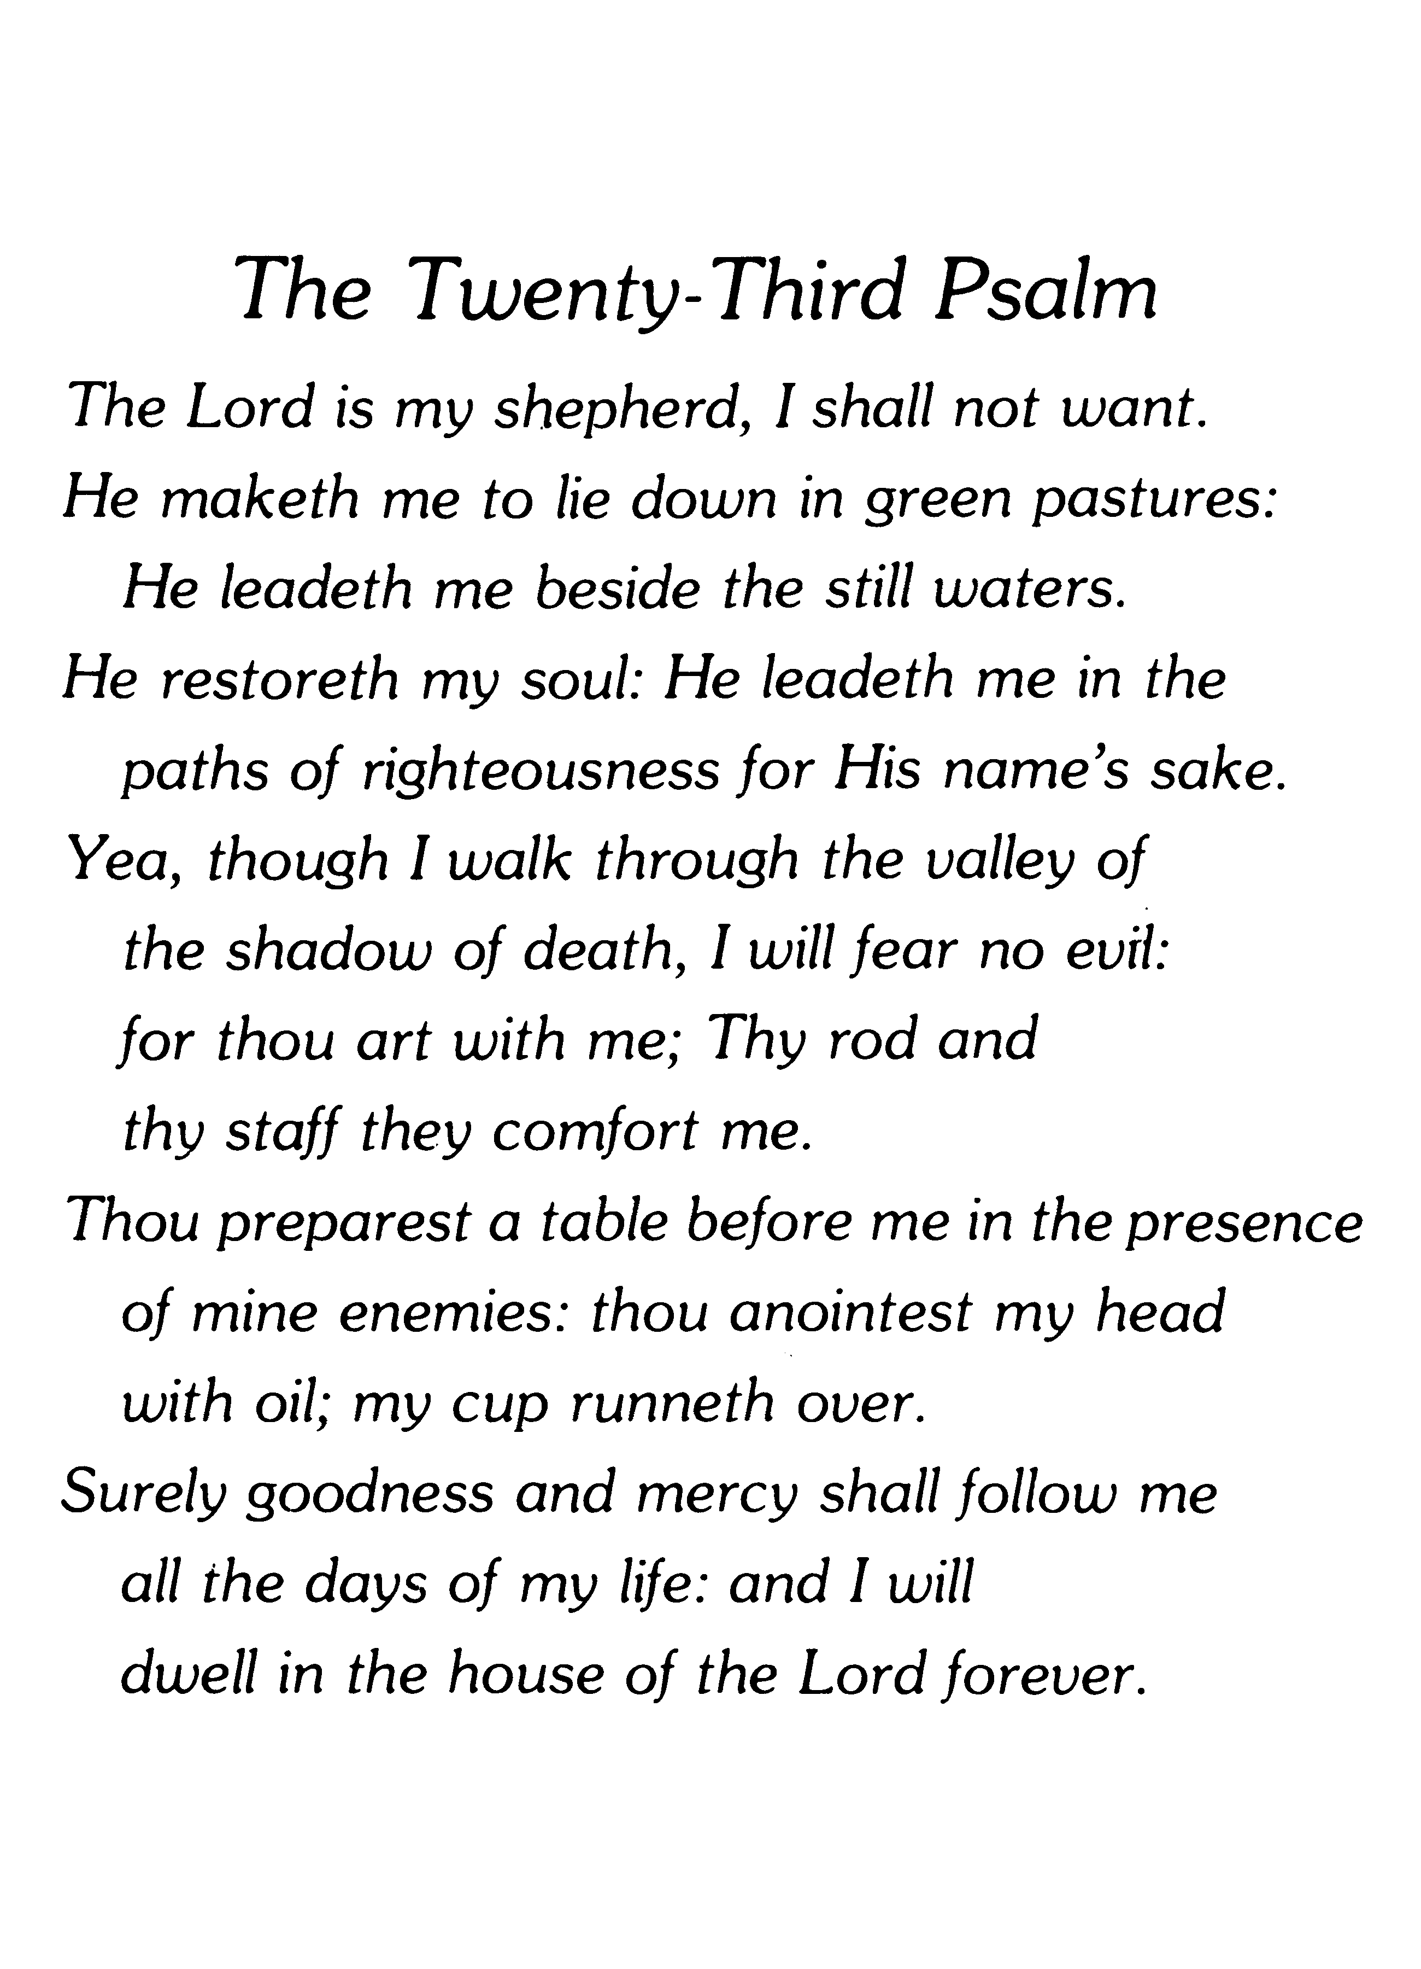
4.Your Loved One’s
Personal Information goes here.

In Loving Memory of

Born

Died

Memorial Service

Officiating
4.Your Loved One’s
Personal Information goes here.

In Loving Memory of

Born

Died

Memorial Service

Officiating
3. Choose one of our Verses
3. Choose one of our Verses

