
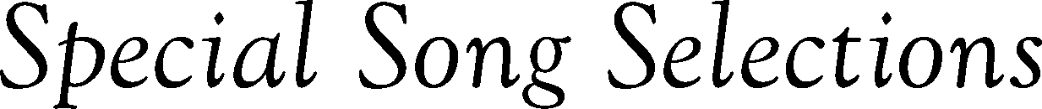
Rendered by
Rendered by
Rendered by
Replace text and press enter to go to the next line.
Replace text
Replace text
Replace text
Replace text
Replace text
Replace text
Replace text

