
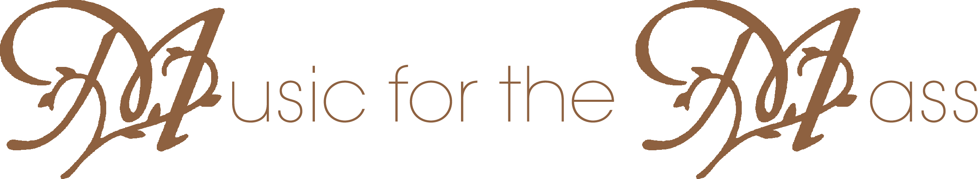
Date
Hour
Held at
Organ
Vocal
Replace text
Replace text
Replace text
Replace text
Replace text
Replace text
Replace text

