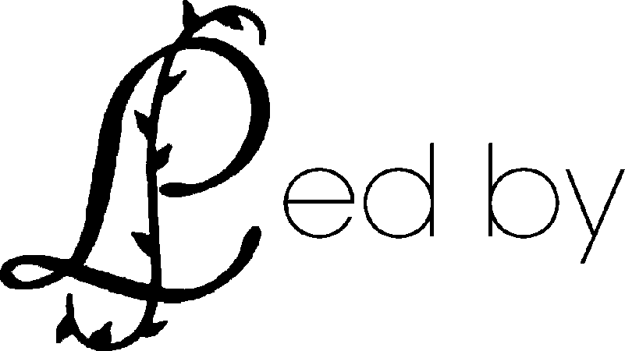
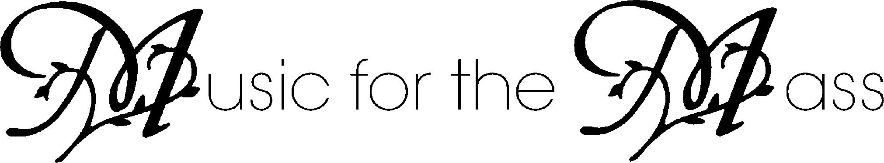
Date
Vocal
Held at
Organ
Hour
Replace text
Replace text
Replace text
Replace text
Replace text
Replace text
Replace text

