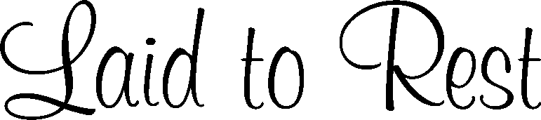
Grave
Lot
Block
Section
City
County
State
Hour
Month Day
Year
Place of Interment
Replace text
Replace text
Replace text
Replace text
Replace text
Replace text

