

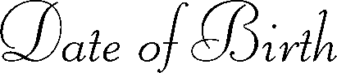


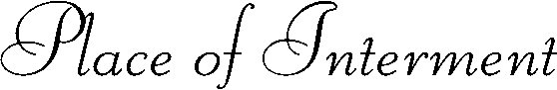

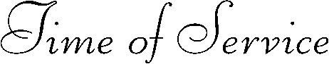
Replace text and press enter to go to the next line.
Replace text and press enter to go to the next line.
Replace text
Replace text
Replace text
Replace text
Replace text
Replace text
Replace text
Replace text

