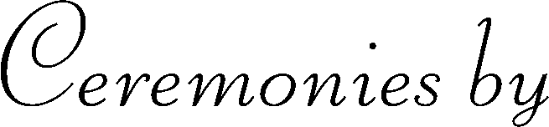
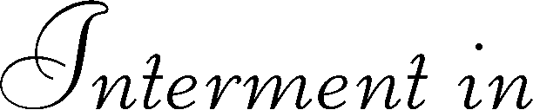
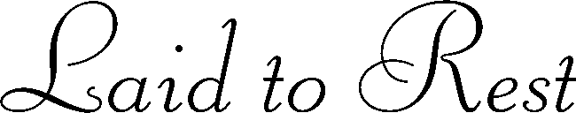
Section
State
Name of Cemetery or Crematorium
County
City
Lot
Block
Hour – Day – Month - Year
Grave
Replace text
Replace text
Replace text
Replace text
Replace text
Replace text
Replace text
Replace text
Replace text
Replace text

