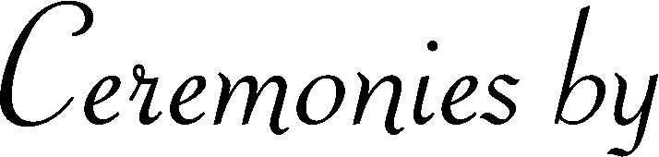


State
Name of Cemetery or Crematorium
County
City
Lot
Block
Section
Hour – Day – Month - Year
Replace text
Replace text
Replace text
Replace text
Replace text
Replace text
Replace text
Replace text
Replace text
Replace text

