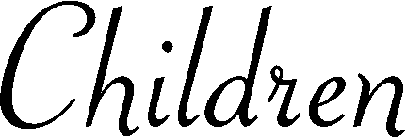
Deceased
Mother
Father
Married to
Replace text and press enter to go to the next line.
Replace text
Replace text
Replace text
Replace text

