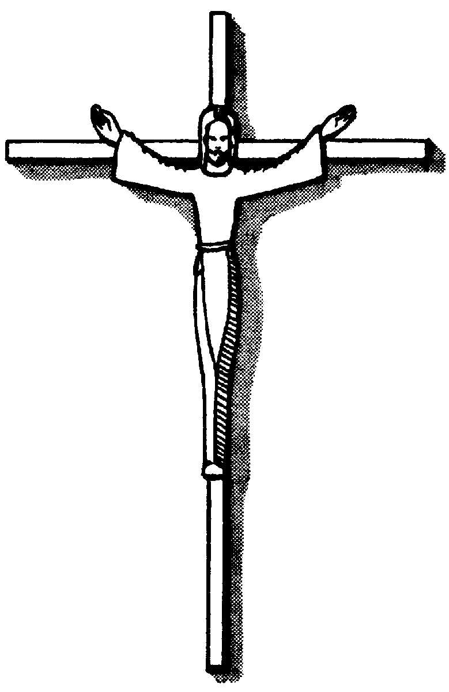
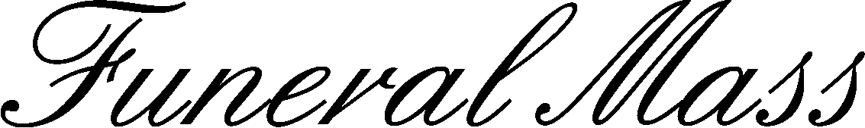

Date
Celebrant
Church
Hour
Replace text
Replace text
Replace text
Replace text and press enter to go to the next line.
Replace text
Replace text

