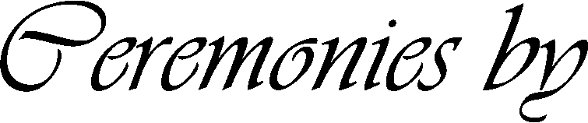


Lot
Block
Name of Cemetery or Crematorium
Hour - Day - Month - Year
County
City
State
Grave
Section
Replace text and press enter to go to the next line.
Replace text
Replace text

