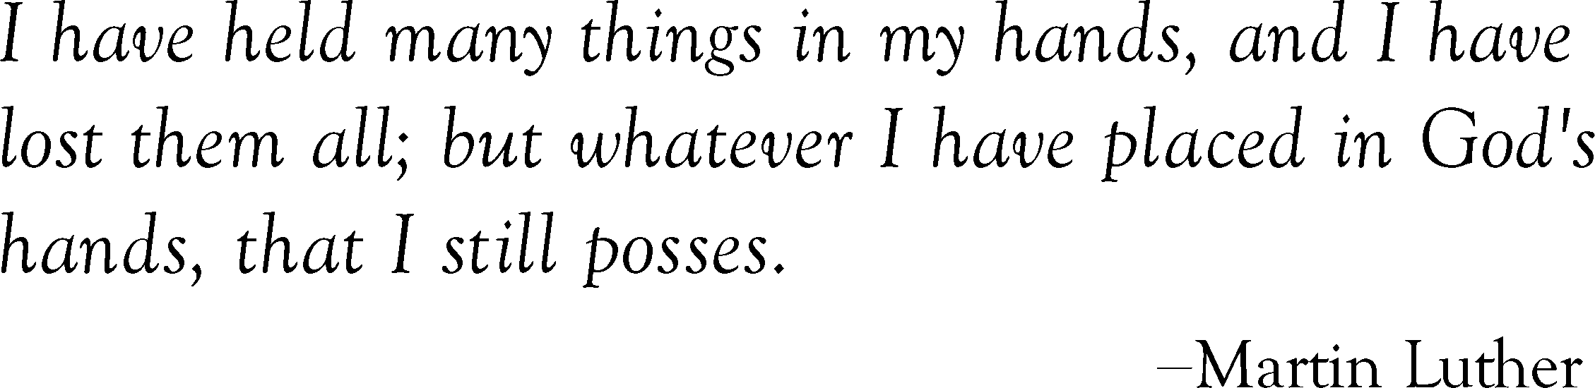
Place of Interment
Year
Section
Month
Hour
Day
Grave
Block
Lot
City
County
State
Replace text
Replace text
Replace text
Replace text
Replace text
Replace text
Replace text
Replace text

