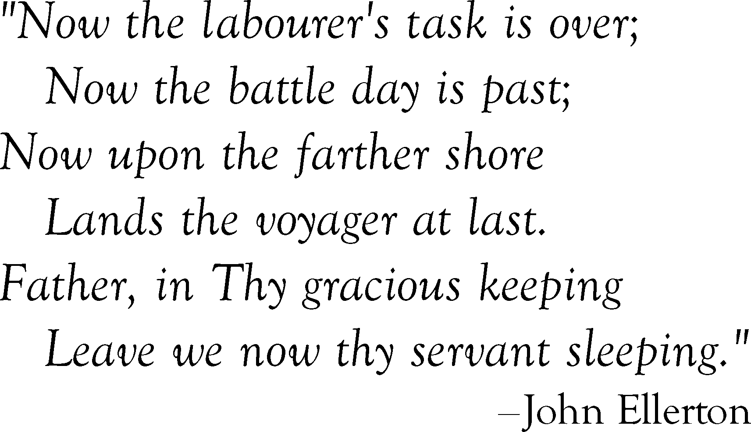
Name
Name
Name
Name
Name
Name
Name
Name

Replace text and press enter to go to the next line.

