1. Typing in the information.
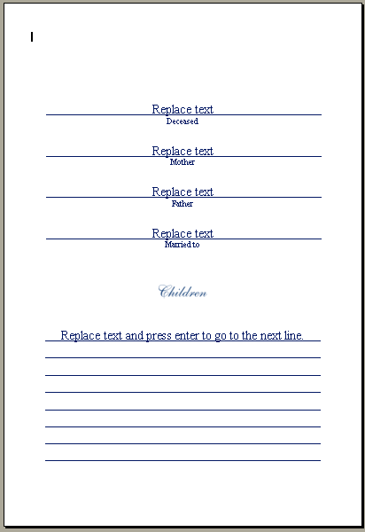
For lines with “Replace text”
Highlight “Replace text” or click in front of text and hit the backspace key until default text is gone. Then type appropriate information. Repeat for each line. If no text is desired on a line, highlight "Replace text" and click Backspace.
This text does not advance to the next line automatically.

For lines with “Replace text and press enter…”
Highlight "Replace text and press enter..." or click in front of text and hit the backspace key until default text is gone. Then type appropriate information.
This text does advance to the next line automatically. Clicking ‘Enter’ will also advance the text to the line below.

2. Formatting the information

Font Style
By default the font is Times New Roman.
The font can be changed to any font style that is on your computer. Font size can be changed, as long as it fits in the text box. Otherwise, all of the text may not be visible when printed.
Bass-Mollett does not provide matching fonts.

Font Alignment
By default, text is aligned to the center of the line. This can be changed, if desired. The “Formatting” toolbar must be visible. If it is not in view, click ‘View’, then ‘Toolbars’, and then ‘Formatting’. Click once in the text box, and select the desired alignment button.

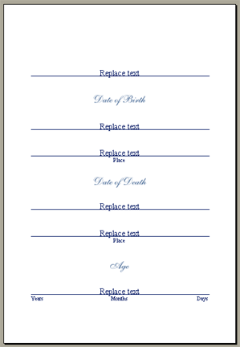3. Customizing the layout

The lines, sub-headings and line descriptions can be removed if desired.

Lines
Lines may be removed by clicking on the right margin once, then press the ‘Delete’ key. This will delete all lines.

Sub-Headings
Sub-headings may be removed by clicking on a sub-heading, then press the ‘Delete’ key. This will delete all sub-headings.

Line Descriptions
Line descriptions may be removed by clicking in the left margin once, then press the ‘Delete’ key. This will delete all line descriptions.

4. Saving “ This step is not required.”

Save to a desired location.

5. Printing

Print to your printer.
Then close Microsoft Word by clicking File, Exit. This will return you back to the Reflections of Life screen.

A basic knowledge of the settings for the printer used to print the pages is necessary, as each printer make and model have different settings. Due to the custom sizing of the Interior Pages, some printers may not be able to print from the normal tray. It will need to be printed from the manual feed tray. Consult the printer manual for more details.

