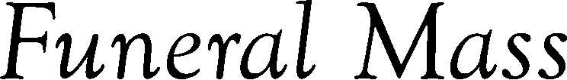

Date
Hour
City
Presiding Priest
Replace text and press enter to go to the next line.
Replace text
Replace text
Replace text
Replace text

