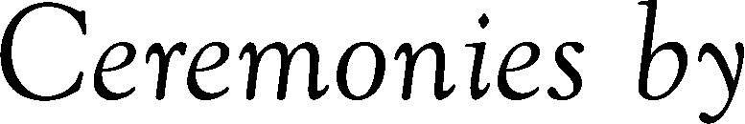

Name of Cemetery or Crematorium
Replace text
Replace text
Replace text
Replace text
Replace text
Replace text
Replace text
Replace text
Replace text

