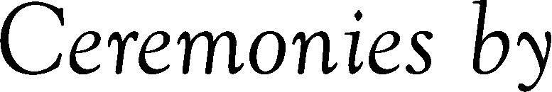


State
Name of Cemetery or Crematorium
County
City
Lot
Block
Section
Day
Month
Year
Replace text
Replace text
Replace text
Replace text
Replace text
Replace text
Replace text
Replace text
Replace text
Replace text

