
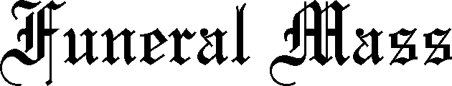

Place
Date
Time
Presiding Priest
Led by
Replace text
Replace text
Replace text
Replace text
Replace text
Replace text
Replace text
Replace text
Replace text

