NOTE: Printing these instructions ahead of time may be helpful.
Requirements of scanned picture size:
Scanning a standard wallet sized picture will automatically be sized for the picture box.
(If the picture is any other size, it will need to be cropped to these dimensions.)
Height: 3” (3 inches)
Width: 2” (2 inches)
Minimum – 150 dpi. Jpeg file

NOTE: Save scanned pictures to the My Documents folder. This will make it easier to find the pictures when they are needed.

Personalizing Back
Opening template:
Click on the desired template from the Prayer Cards page.

Printing instructions:
We recommend printing the template on a blank sheet of paper. Then placing the Prayer Card behind the template, checking for alignment. If they line up to your specifications, simply save in a desired location and go to Step 1.
If the template does not line up well, follow these simple instructions:

For Picture Boxes
Click once on a shaded picture box. (The picture boxes are grouped together for a more precise alignment.) Hold the Control key while using the directional keys to nudge the set of pictures to the desired location.
For Text Boxes
The text boxes are also grouped together. Click once on the text to highlight the text box. Then click on the shaded outline, to select all the text boxes as a group. Hold the Control key while using the directional keys to nudge the set of text boxes to the desired location. Once they line up to your specifications, save to a desired location and proceed to Step 1.

Step 1, Inserting pictures - Double click on the shaded area. (Remember – the picture boxes are grouped, so the inserted picture will appear in all picture boxes.) Select Format AutoShape. Choose the Colors and Lines tab. In the Fill area, click on the Color box and choose Fill Effects. Click on Picture tab. Choose Select Picture. Find the desired picture, highlight, and click Insert.
Or Follow the illustration below

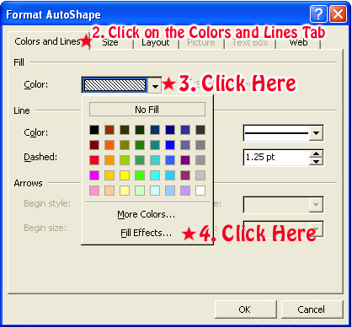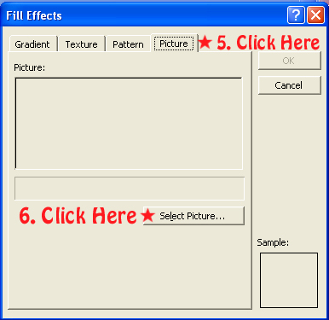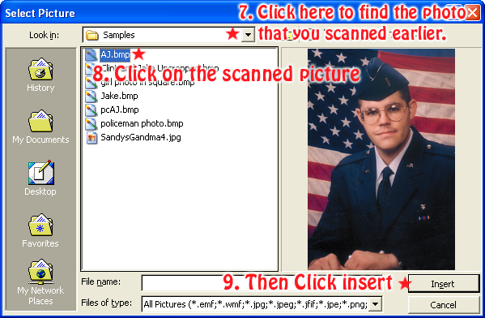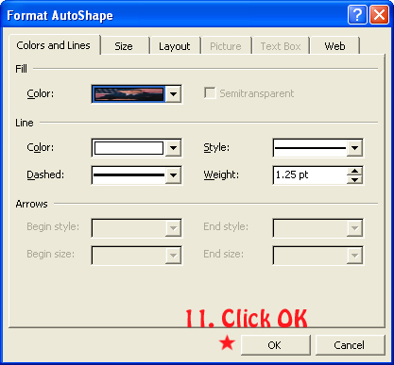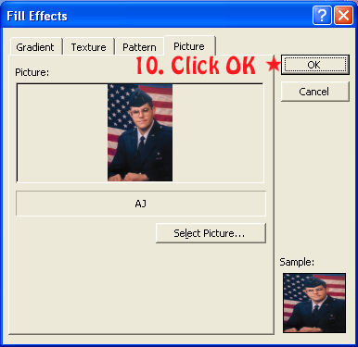

Step 2 – Inserting text – To insert the name and date, click once on Deceased Information. Clear the text and type the desired text. Repeat this step for each Prayer Card on the page or copy and paste into each prayer card.

Step 3 – Save to a desired location before proceeding. (optional)

Step 4 – Simply print to your printer.
Then close Microsoft Word by clicking File, Exit. This will return you back to the Reflections of Life screen.

