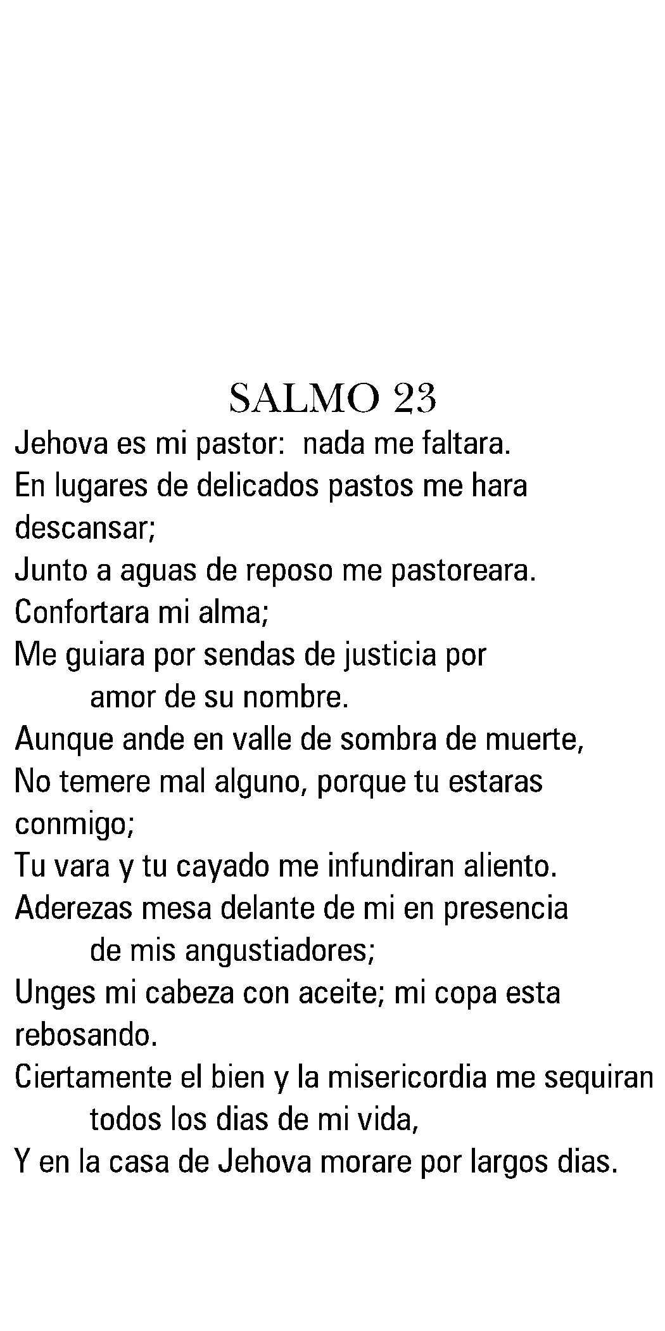

Deceased Name
Date of Birth
Date of Death

Deceased Name
Date of Birth
Date of Death

Deceased Name
Date of Birth
Date of Death

Deceased Name
Date of Birth
Date of Death

Deceased Name
Date of Birth
Date of Death

Deceased Name
Date of Birth
Date of Death

Deceased Name
Date of Birth
Date of Death

Deceased Name
Date of Birth
Date of Death

