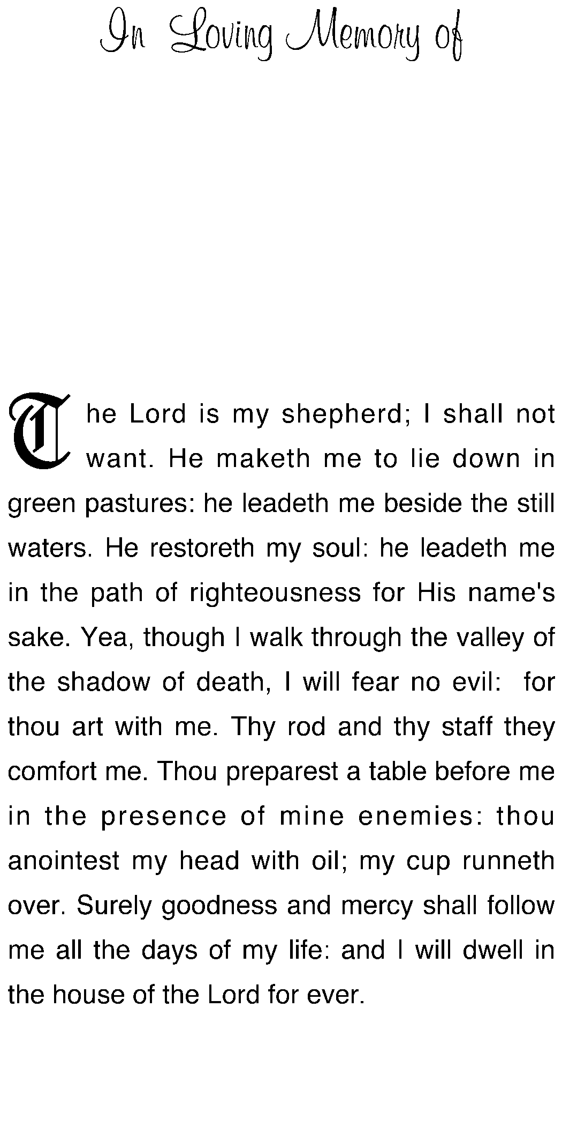

Deceased Name
Date of Birth
Date of Death

Deceased Name
Date of Birth
Date of Death

Deceased Name
Date of Birth
Date of Death

Deceased Name
Date of Birth
Date of Death

Deceased Name
Date of Birth
Date of Death

Deceased Name
Date of Birth
Date of Death

Deceased Name
Date of Birth
Date of Death

Deceased Name
Date of Birth
Date of Death

In Loving Memory of
In Loving Memory of

In Loving Memory of

In Loving Memory of

In Loving Memory of

In Loving Memory of

In Loving Memory of

In Loving Memory of

