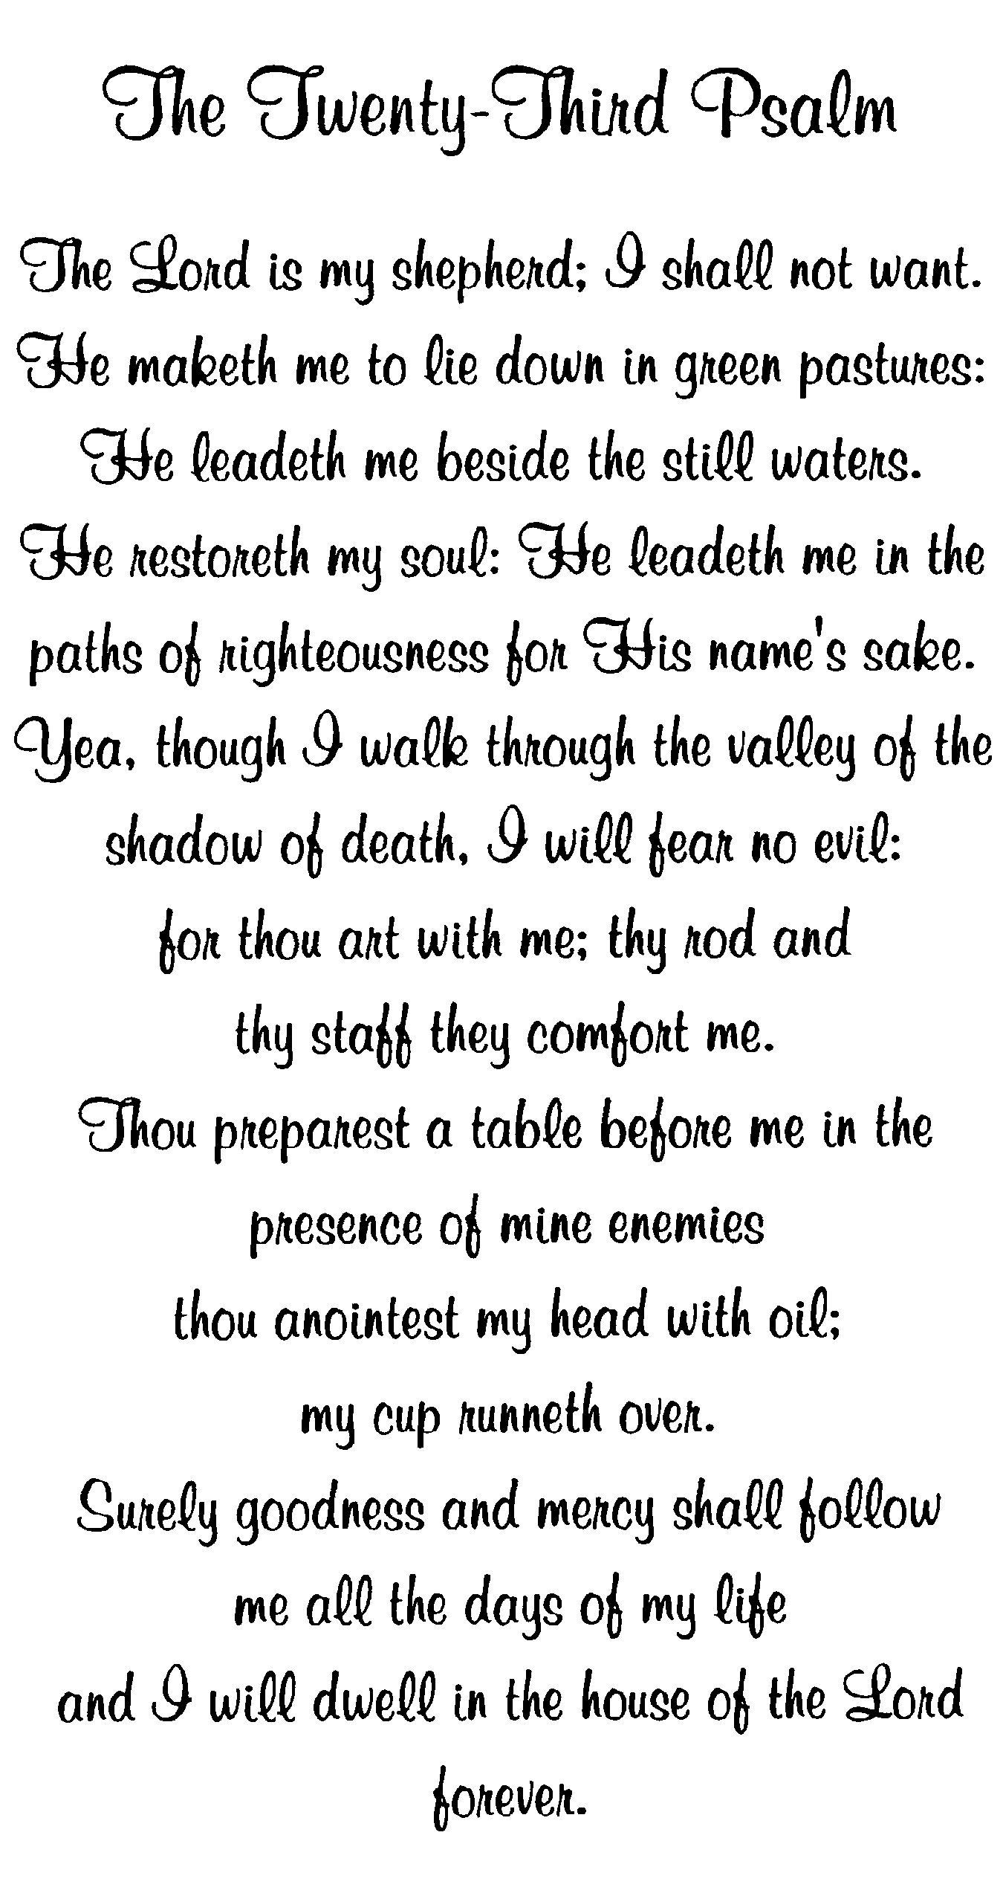
Funeral Home Imprint
Funeral Home Imprint
Funeral Home Imprint
Funeral Home Imprint

