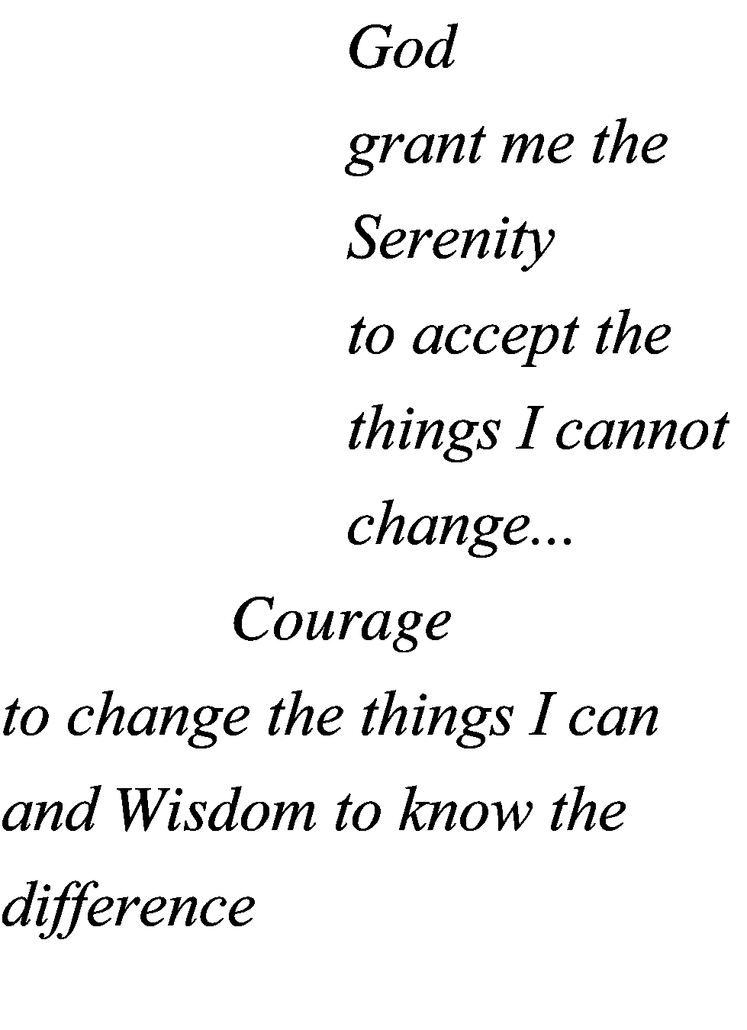
In Memory of

Date of Birth

Date of Death

Service

Clergy

Final Resting Place

In Memory of

Date of Birth

Date of Death

Service

Clergy

Final Resting Place

