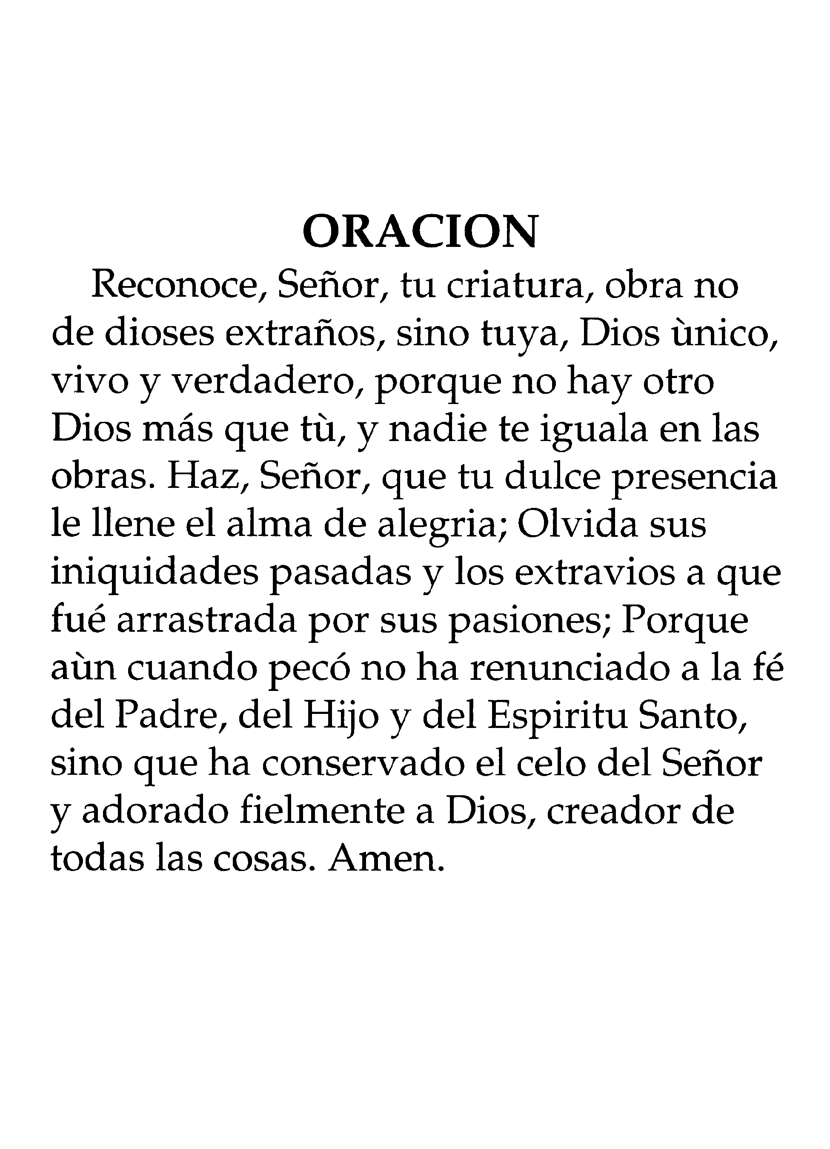
In Loving Memory Of
Replace text with deceased name

Place and Time of Services
Replace text
Clergy
Replace text
Place of Interment
Replace text
Casket Bearers
Replace text

Date of Birth
Replace text

Date of Death
Replace text

In Loving Memory Of
Replace text with deceased name

Place and Time of Services
Replace text
Clergy
Replace text
Place of Interment
Replace text
Casket Bearers
Replace text

Date of Birth
Replace text

Date of Death
Replace text

