NOTE: Printing these instructions ahead of time may be helpful.

Requirements of scanned picture size:
Scanning a standard wallet sized picture will automatically be sized for the picture box.
(If the picture is any other size, it will need to be cropped to these dimensions.)
Height: 3” (3 inches)
Width: 2” (2 inches)
Minimum – 150 dpi. Jpeg file

NOTE: Save scanned pictures to the My Documents folder. This will make it easier to find the pictures when they are needed.

Personalizing Front/Back
Opening template:
Click on the desired template from the Service Records page.

Printing instructions:
Due to the inconsistencies between printers, aligning the picture boxes and text boxes before inserting the pictures and text will save time and ink. We recommend printing the template on a blank sheet of paper. Then placing the Service Record behind the template, checking for alignment. If they line up to your specifications, simply save in a desired location and go to Step 1.
If the template does not line up well, follow these simple instructions:

For Picture Boxes
Click once on a shaded picture box. (The picture boxes are grouped together for a more precise alignment.) Hold the Control key while using the directional keys to nudge the set of pictures to the desired location.
For Text Boxes
The text boxes are also grouped together. Click once on the text to highlight the text box. Then click on the shaded outline, to select all the text boxes as a group. Hold the Control key while using the directional keys to nudge the set of text boxes to the desired location. Once they line up to your specifications, save to a desired location and proceed to Step 1.

Step 1, Inserting pictures -Double click on the shaded area. (Remember – the picture boxes are grouped, so the inserted picture will appear in all picture boxes.) Select Format AutoShape. Choose the Colors and Lines tab. In the Fill area, click on the Color box and choose Fill Effects. Click on Picture tab. Choose Select Picture. Find the desired picture, highlight, and click Insert.
Or Follow the illustration below

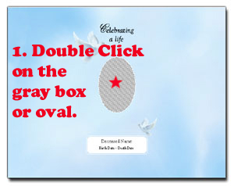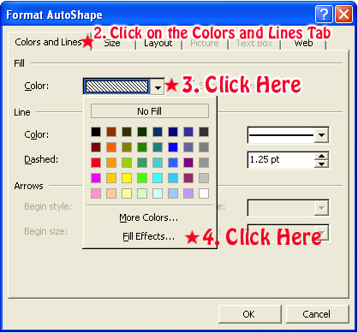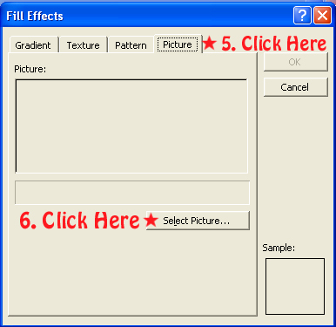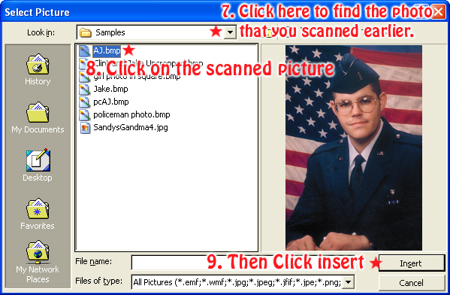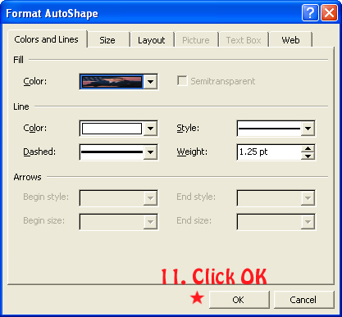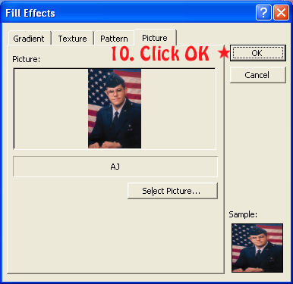

Step 2 – Inserting Name – To insert the name of the deceased, delete Enter Deceased Name and type name.

Step 3 – Inserting text – To insert the desired text, click once on Replace text with the service information. Clear the text and type the desired text. There is also a text box provided for a Funeral Home Imprint. If this information is preferred, simply clear text and type desired text. If this information is not wanted, simply clear the text box.

Step 4 – Click File Save as, and save to a desired location before printing. (Optional)
After printing close Microsoft Word by clicking File, Exit. This will return you back to the Reflections of Life screen.

Personalizing Inside with Picture/Service Info or Verse/Service Info

Opening template:
Click on the desired template from the Service Records page.

Printing instructions:
All text boxes (including the verses) are grouped together. Click once on the text to highlight the text box. Then click on the shaded outline, to select all the text boxes as a group. Hold the Control key while using the directional keys to nudge the set of text boxes to the desired location. Once they line up to your specifications, save to a desired location and proceed to Step 1.

Step 1 – To insert text, click once on Replace text with the service information. Clear the text and type the desired text.
(NOTE: If no text is desired, simply delete the words Replace text with the service information.

Step 2 – Repeat Steps 1 and 2 for each Service Record on the page. Tip: Type the service information once and copy and paste it to the second text box this will save you from typing it twice.

Step 3 – Click File Save as, and save to a desired location before printing. (Optional)
After printing close Microsoft Word by clicking File, Exit. This will return you back to the Reflections of Life screen.

