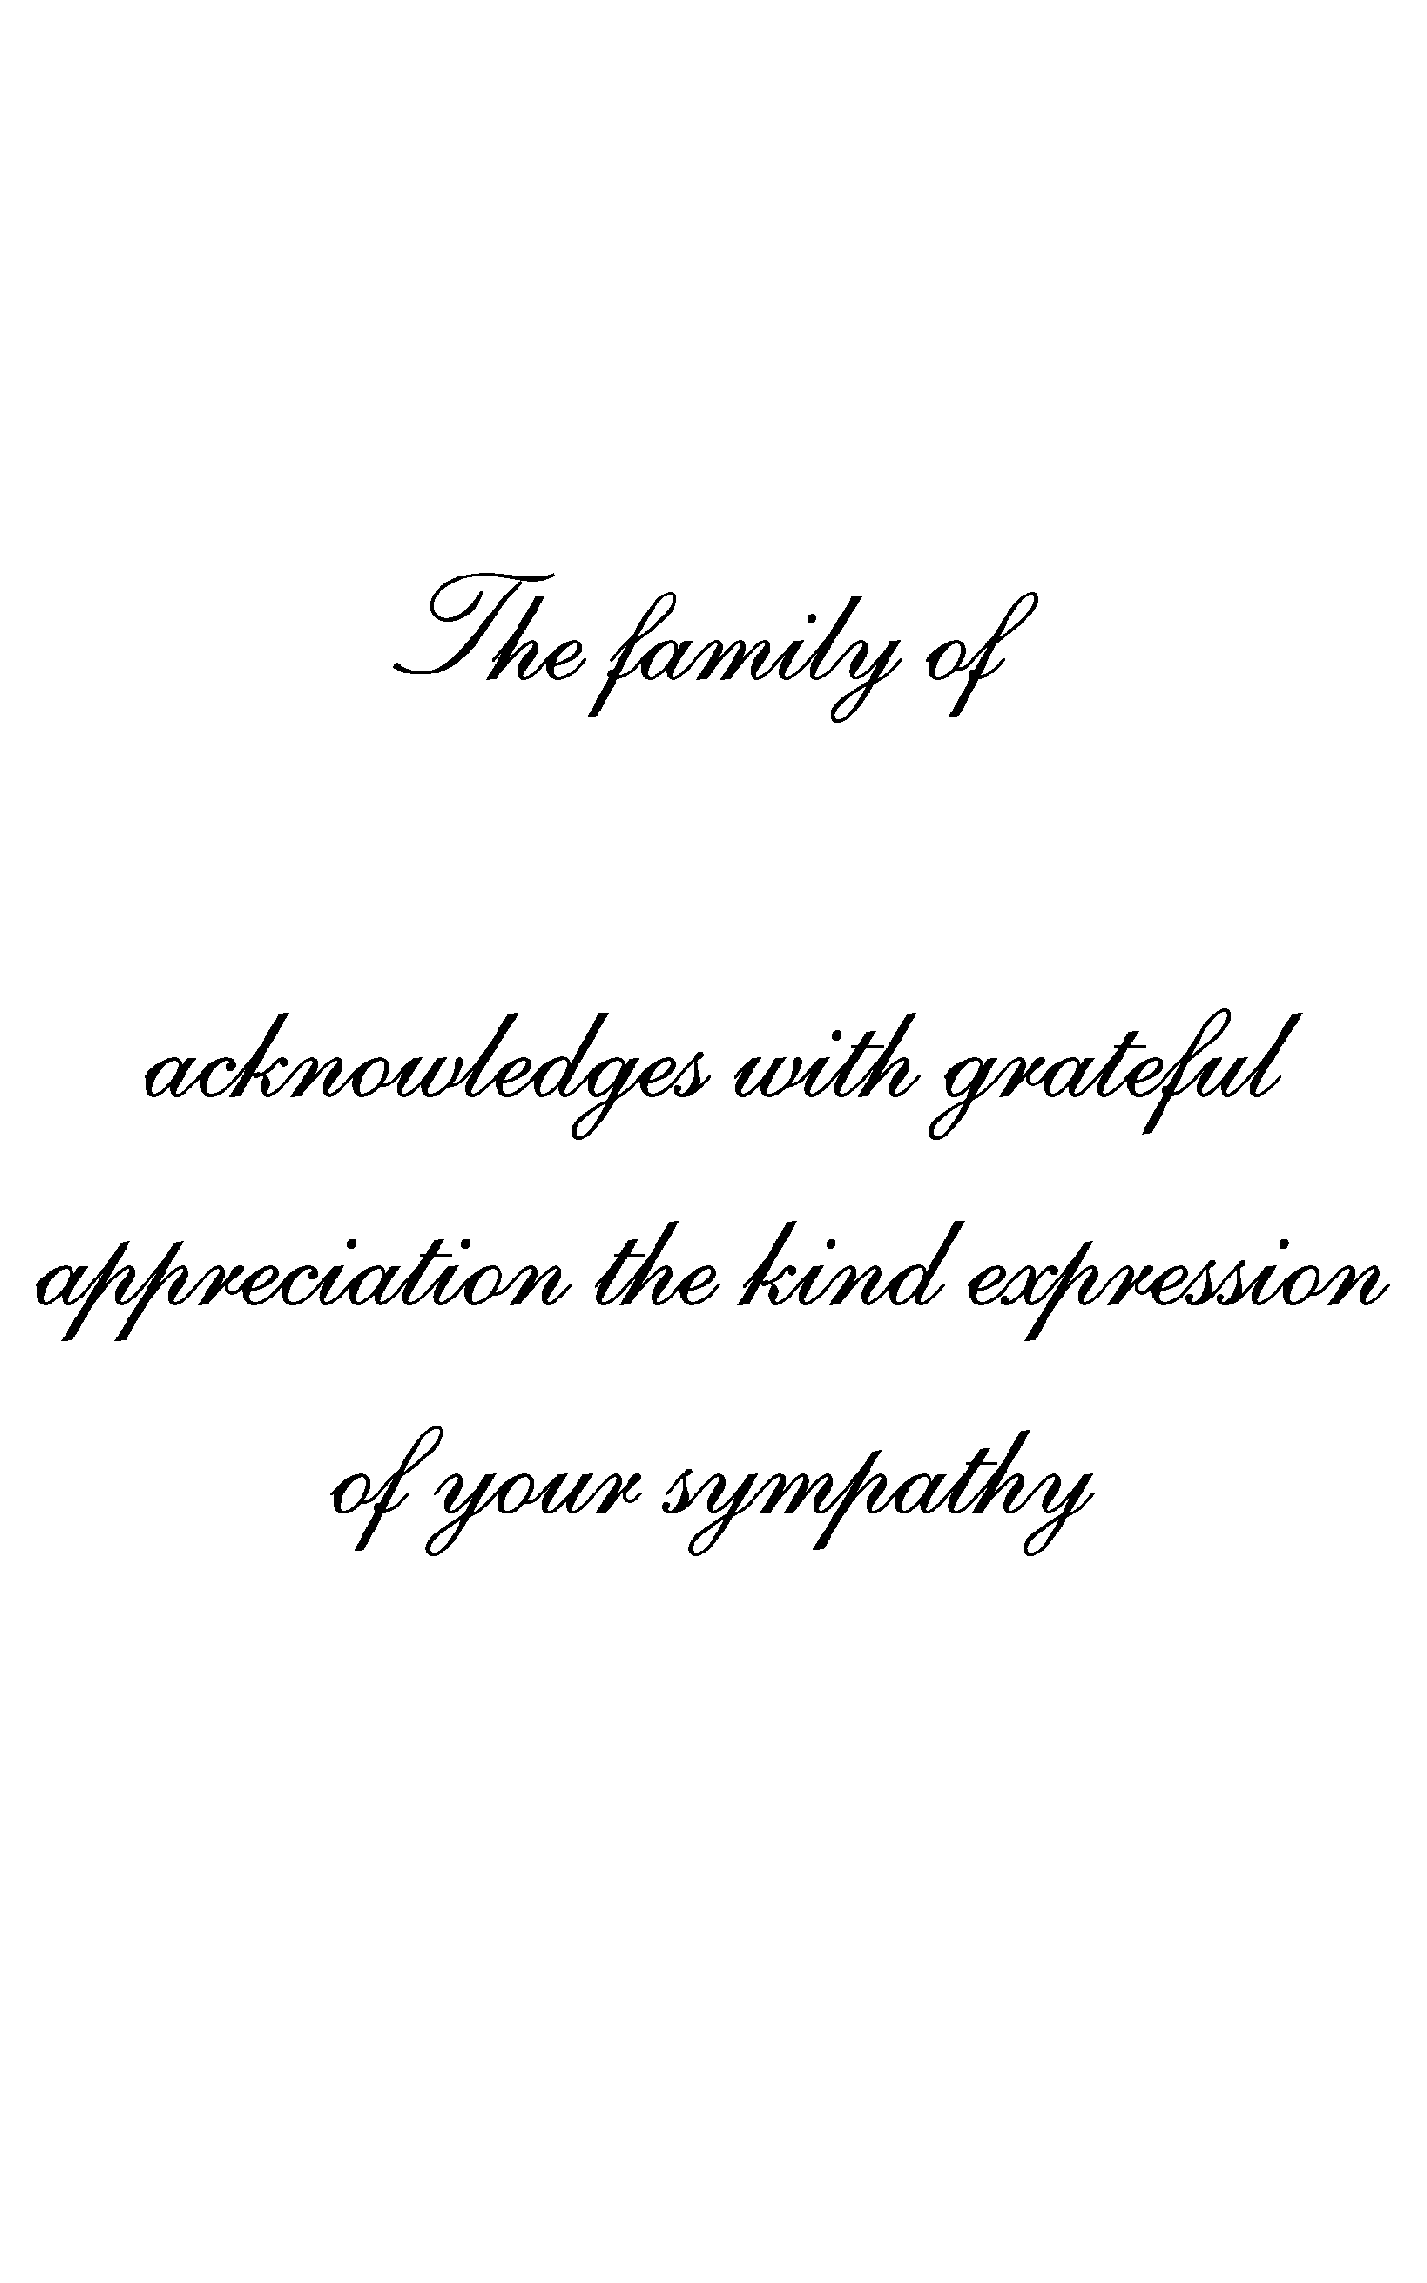
Replace text with a verse or statement, if not highlight and delete text.
Replace text with a verse or statement, if not highlight and delete text.
Deceased Name
Deceased Name

