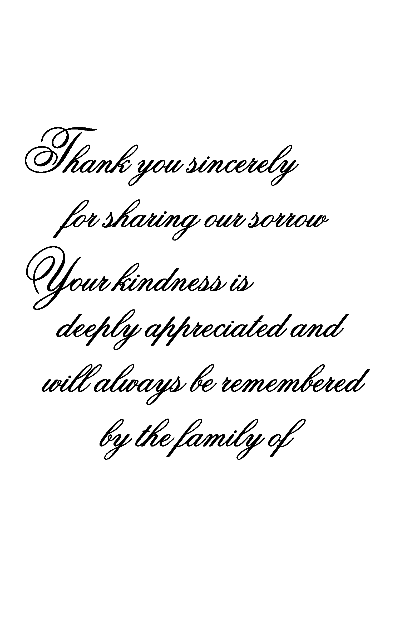
Deceased Name
Deceased Name
In Loving Memory Of
Deceased Name
In Loving Memory Of
Deceased Name

