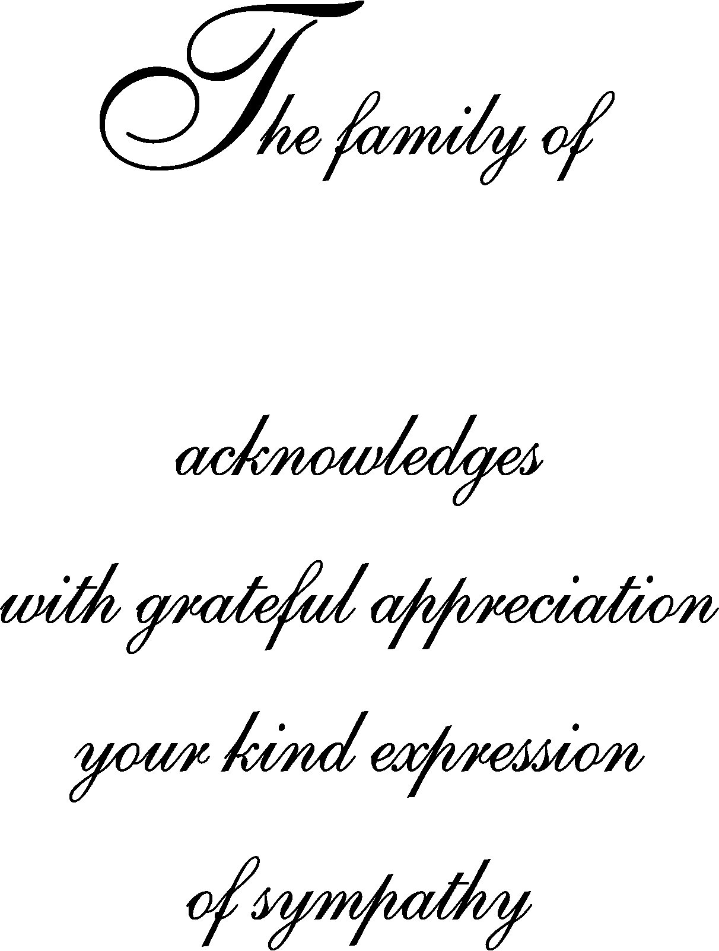
In Loving Memory of
Deceased Name
In Loving Memory of
Deceased Name
Deceased Name
Deceased Name

