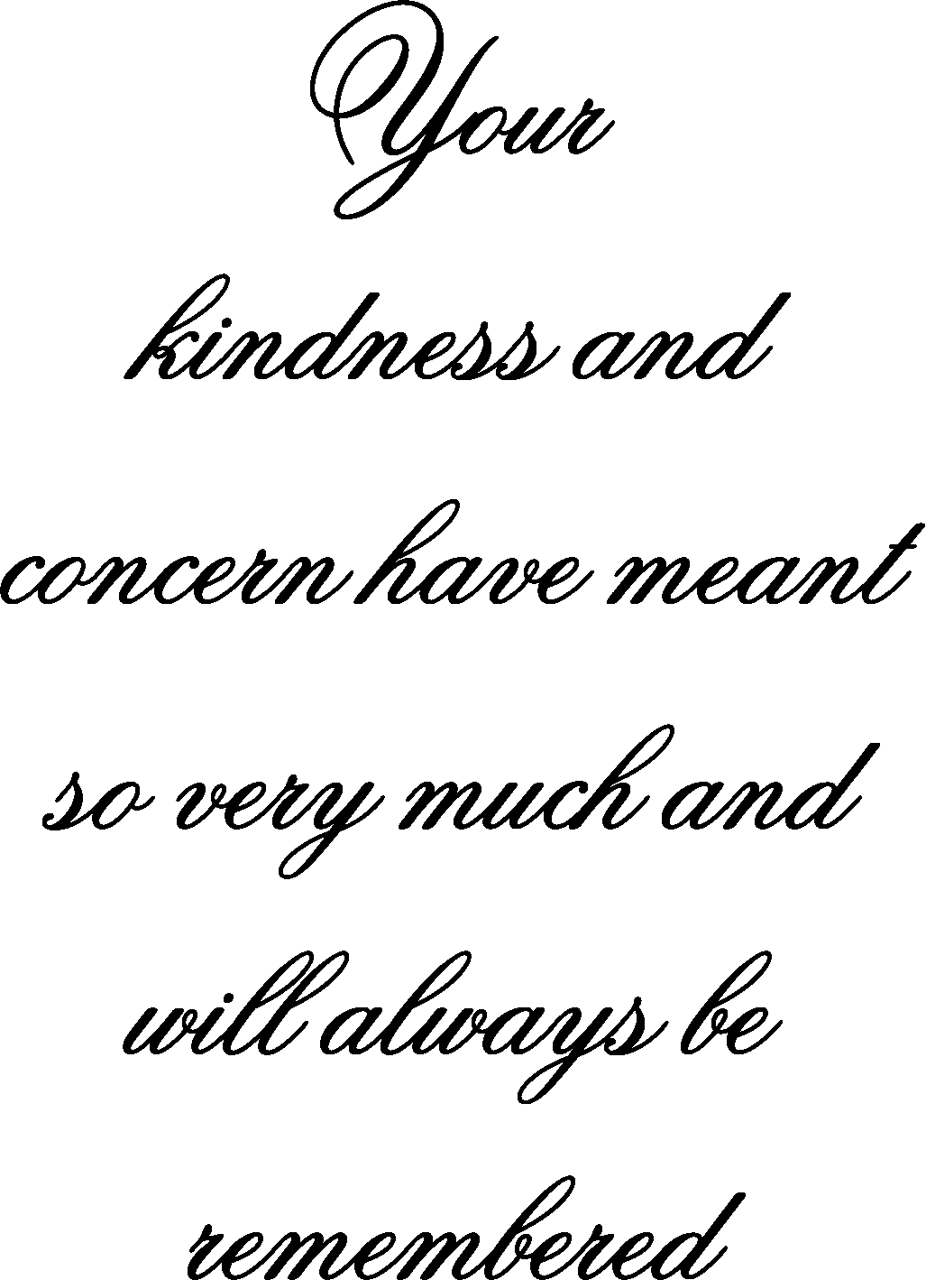
Replace text with verse or statement, if not highlight and delete text.
Replace text with verse or statement, if not highlight and delete text.

