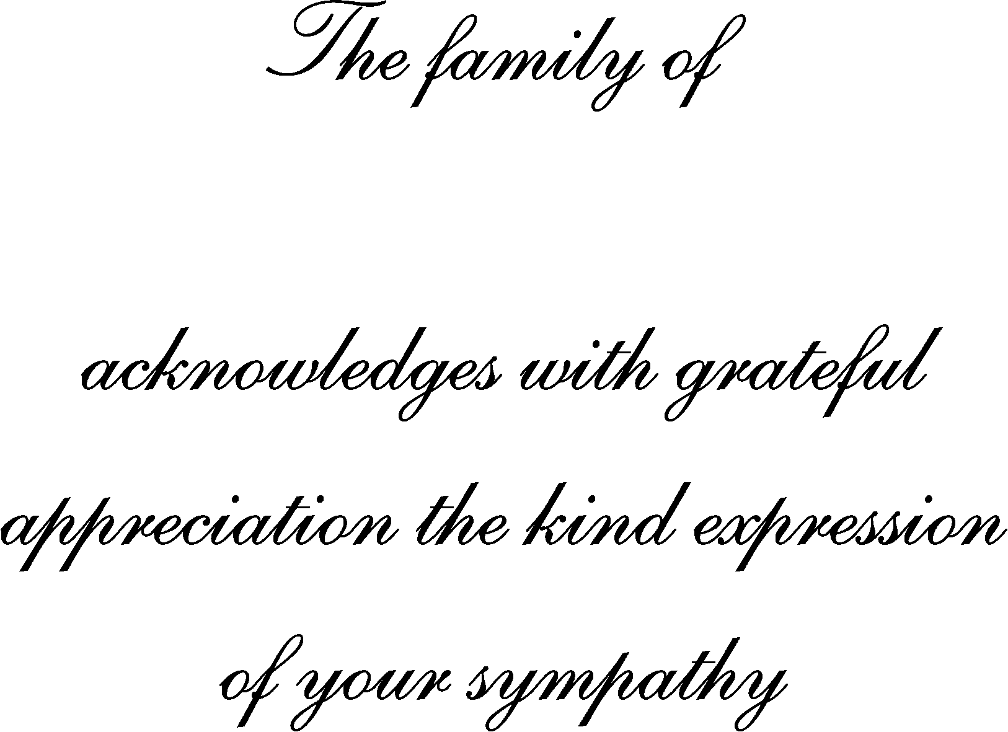
Deceased Name
Deceased Name

